

OTTAWA LITTLE THEATRE Production Manual
2026 Season

TABLE OF CONTENTS

INTRODUCTION - USE of MANUAL 3
SECTION 1 - SAFE, SECURE AND FUN ENVIRONMENT 4
SECTION 2 - PRODUCTION SCHEDULING 6
SECTION 3 - THE PROCESS - FROM PAGE TO STAGE………………………………… 11
SECTION 4 - COMMUNICATIONS INFO 32
SECTION 5 - HEALTH AND SAFETY 36
SECTION 6 – EMERGENCY PROCEDURES 38
SECTION 7 – INDEX OF ONLINE RESOURCES 40

INTRODUCTION - USE of MANUAL

Welcome to YOUR community theatre. The OLT is a unique, wondrous and busy place. With nine shows in production every season, the theatre has over 300 volunteers at work – nine different production teams under the management of nine different directors, ADs, designers and crews, supported by many volunteers at the front-of-house.

Most of the time there are three full productions actively on-site, in various phases of preparation, getting “to-stage” or actually “on-stage.” The stage and the building are in use almost 50 weeks of the year. That is a lot of traffic and potentially a lot of wear and tear. It is everyone’s responsibility to take care of the place like it’s your own, have a great time while in it, and leave it in the best possible shape when you leave!

This manual should be a “must read” by all cast and crew to ensure everyone involved in a production understands the processes, and the roles and responsibilities of your production team and theatre personnel.

It is intended as a guide to help manage all that traffic and keep the building safe. It is the cumulative input of almost everyone who has ever mounted a production at OLT, and it should help facilitate the use and enjoyment of the theatre. It also should, and eventually will, contain everything you need to know (or who to call to get answers) to operate safely and successfully on-site, and to enjoy your theatre experience.

It is a “living” document and is periodically updated and modified as changes to activities and events dictate. By way of overview:
- Section 1 – explains safety and security
- Section 2 – details the facility and production scheduling process
- Section 3 – provides the “hows” and “whats” of the show production process
- Section 4 – highlights the communication processes
- Section 5 – deals with health and safety
- Section 6 – emergency procedures
- Section 7 – Website links to procedures, useful forms, and production team “job” descriptions.

Thank you for joining the OLT family. We all appreciate the work and effort you and hundreds of other volunteers invest in the productions. Without that effort, there would be no theatre. If you have any questions or concerns, there will be someone at the theatre who will be happy to help!

SECTION 1 - SAFE, SECURE AND FUN ENVIRONMENT

Everyone involved in Ottawa Little Theatre works hard to provide a pleasant, safe, and secure working facility. It is critical that all production teams respect the theatre spaces and property, and the shows and activities on-site. Everyone is a volunteer, so please help each other and support each other. The theatre belongs to you, but also to those who come after you.
Directors are fully responsible for safety from the beginning of the rehearsal process through to when the production “goes up” on stage at which point the Stage Manager takes over the process. Directors can delegate tasks, but they cannot delegate the responsibility for a safe/secure work environment. Please ask for guidance or assistance if uncomfortable with any part of the production process.

During business hours, access to the theatre is monitored by box office staff. Outside of box office hours, each production team is responsible for monitoring access. Anyone downstairs or backstage whom you do not recognize can be questioned. If you are not satisfied with the answer or if you have trouble, please call for assistance:

A list of emergency numbers is posted in the Rehearsal Hall, the Green Room, the workshop, and at the service desk in the upper lobby, box office and Health and Safety notice board.
A copy of our emergency evacuation plan appears further on in this manual.

Please Note:
Ottawa Little Theatre has a Respectful Workplace Policy on how to deal with possible or actual Violence/Harassment in the Workplace.

A hard copy is posted on the Health and Safety Board downstairs, the Rehearsal Hall, Green Room, Box Office and Business Office.
The Respectful Workplace Policy is also available to download from OLT’s website - located under “Volunteer”.

Please familiarize yourself with this document and encourage your cast and crew to read it.

PLEASE NOTE:
- there is no smoking permitted anywhere in the building
- the theatre must be secured each night by one of the following: Director, AD, SM, or member of the Board of Directors.
- last person to leave, must ensure:
- all small appliances off:
    - kitchen (stove)
    - green room/rehearsal room (coffee machine)
    - dressing room (e.g. curling irons)
    - wardrobe (e.g. iron)
    - workshop (lights)
- all internal lights off - external lights are left on at night

- all external doors locked:
    - front doors
    - stage door
    - emergency (crash) door on King Edward Ave
- internal doors on the Rehearsal Hall level to the House and Stage, top and bottom of stairwells closed.

KEY CONTACTS
OLT main number - 613-233-8948
BOX OFFICE – 613-233-8948
Technical Director (TD)- (613-791-2630)  Carpenter/Stage Technician(613-879-0106) | Tom Pidgeon  Damian Piper | tom@ottawalittletheatre.com  damian@ottawalittletheatre.com
Production Support (PS) (613 852-2548) | David Magladry | david.magladry@gmail.com

BOARD OF DIRECTORS

Albert Lightstone (President)
Paul Hession (Facilities and Capital Assets)
Michelle Shortall (Administration)
Marilena Guerra (Treasurer)
Michel Cormier (Technical)
Lindsay Laviolette (Education/Training)
Robert Hicks (Digital)
Venetia Lawless (Theatre Outreach)
Christian Giansante (Promotions and Publicity)

COMMITTEE Chairs
- ARCHIVE – Jane Morris
- ARTISTIC QUALITY – Venetia Lawless, Lindsay Laviolette
- SEASON PLANNING - Jane Morris
- COMMUNICATIONS (COLT) – Jane Morris
- COSTUMES (SWAG) - Nancy Hogan
- PROPERTIES (POLT) - Val Bogan
- EODL - Val Bogan
- VOLUNTEER (VOLT) – Linda Webster
- LEARNING (LOLT) – Lindsay Laviolette
- National One-Act Playwriting Competition – Bob Hicks

EMERGENCIES and INCIDENTS

In the event of an Emergency (life threatening, crimes in-progress, drug dealing)
- Call 911 - You can call Police for non-emergences on 613-230-6211
- For a medical emergency find a First Aider - staff and front of house managers are trained

First Aid Kits are located at:
- Stage Manager’s station
- Workshop to the left of Production Office door
- Service desk in upper foyer
- Coat Check Room in the lower foyer (desk drawer)
- Defibrillators are located beside the bar and lower level by stairs to stage

SECTION 2 - PRODUCTION SCHEDULING

Each production team will receive a production schedule showing audition dates, production and post-production meeting, rehearsal days and times, and stage days and times. It is then up to the Director and ADs to work out full detailed schedules. Each team will also receive a schedule of dates program information is to be provided to Val Bogan. No production team members can be onstage, backstage, in the booth or workshop weekdays until after 3:00 pm unless pre-arrangements are made with the Technical Director at any time throughout the run of the rehearsals/show.

Members of the Artistic Quality Committee may reach out to each production director to arrange to join at least one Production Meeting and a few rehearsals once the rehearsals move into full runs. The Artistic Quality Committee members represent the OLT governance and are there to identify any supports needed within the production and to get an objective view to how the production is taking shape. Their role is to support the process and serve as an additional resource to productions.

The OLT has implemented a vocal training initiative through which a vocal coach will be assigned to each production to provide the outline of a vocal warm up that should be repeated during the rehearsal period and regimented during the run. The vocal coach will also be a resource for directors to turn to if they need individual cast members to have some one-on-one training. While coaches are not speech pathologists, they have received some OLT vocal training and will be able to serve as a resource to productions. As of the release of this version of the production manual, it is mandatory that productions implement some form of vocal warmups to improve audibility and intelligibility of our performers regardless of their experience.

When required, the OLT requires a qualified Intimacy Coordinator be contacted to work with your cast. Shauna Akkermans has worked with OLT productions – she can be contacted at shauna.akkermans@yahoo.com to make arrangements.

Each production has a Volunteer Liaison who is available to help with problems or questions. The VL can support communications as needed with other departments and with the board if necessary. The VL’s contact info is posted in the RH, the GR and appears on each show’s contact list.

First step: drafting a detailed schedule
The whole production process – from before first audition to after closing night – takes from 16 to 20 weeks. And, schedules will likely change due to cast/crew availability, work requirements, etc.

Each production team needs to
- identify what will be needed and when:
- production and design meetings
- prepping audition notices
- pre-production duties
- rehearsal times and specifics
- strikes/returns/clean-up times
- other post-production duties
- designers’ requirements at rehearsals, run-through(s)

- include the two on-stage production weeks – be prepared to adjust:
- if the lighting designer has not completed the hang and focus, levels cannot be checked
- if video footage or “running crew” are used, extra rehearsal time may be required
- highlight when tech staff need be on-hand to run lighting, sound or projection
IMPORTANT NOTE
It goes without saying that the Director makes the final decision on the artistic vision of the production regardless of what stage it is at. If there is a disagreement, the parties should do their best to work it out. However, the decision of the Director is final.

Weeks 1 - 4: Preparation/Casting
- auditions are usually scheduled for the main stage on the Saturday following the opening of the show two slots ahead of yours
- auditions times/dates are assigned by the TD
- any scheduling concerns should be discussed with the TD ASAP
- call backs can take place in the Rehearsal Hall as noted in the rehearsal schedule
Week 5 - 14: Rehearsals (dates provided by TD on sheet in your package)
- the first four weeks of rehearsal are on Tuesdays, Thursdays and Sunday (note: you will begin on the Thursday of the first week)
- on the 5th week the rehearsals switch to Monday, Wednesday and Friday evenings, as well as Sunday (note: you will begin on the Wednesday of the fifth week)
- week 7: technical elements - construction and painting of the set - usually begin. With blocking of the cast and locations of set elements established, sound and lighting designers can get engaged
- last 2 weeks in the Rehearsal Hall: time for runs of the entire play and invite crew. The running crew gets to know the show, and the cast and crew get to meet
- two or three weeks before opening, needed head shots required will be taken
- no production members can be onstage, backstage, in the booth or workshop weekdays until after 3:00 pm unless pre-arrangements are made with the Technical Director at any time throughout the run of the rehearsals/show

Week 15 - 16: Onstage/Tech Weeks
- on the first Tuesday the play moves “on-stage” for rehearsals
- over the first week the set is finished, and all the technical elements are added
- during the second week all elements are rehearsed together

- scene-specific work can still be done with technical elements in place
- Wed or Thurs of the 2nd week on stage is usually when production photo/videos/publicity take place
- if this is a full-dress rehearsal, scenes may be set up for photos and the photographer takes photos during the run-through.
- external publicity (newspapers or TV stations) could be on this night as well.
- during the last weekend there could be a Benefit Preview – a reserved performance with tickets sold as a fundraiser by a charitable organization

Week 15 - 17: Performance/Strike
- production opens Wednesday night with performances on Wednesday to Saturday nights at 7:30 pm and two Sunday matinees at 2:30 pm.
- crew call is 6:30 pm (1:30 pm on Sunday) to prep stage, props, costumes, lighting, sound, and all special effects prior to opening the house to audiences - usually at 7pm (2pm on Sunday).
- patrons with reduced mobility may be seated before the house opens (often as early as 6:30 / 1:30)
- if required by the production, certain crew calls may be pushed forward
Wednesday through Saturday | Sunday
call is 6:30 pm | call is 1:30 pm
house opens at 7:00 pm | house opens at 2:00 pm
curtain at 7:30 pm | curtain at 2:30 pm

Week 18: Final Clean-Up and Post-Production Meeting
- Saturday night strike - remove set, lighting and sound equipment from stage after performance
- to speed up the transition between our productions
- all costume/props items are to be cleaned and returned promptly to their proper place
- Post-production meeting led by the Artistic Committee is usually scheduled for the Tuesday after closing night
- opportunity for lessons learned, best practices and continuous improvement

Typical Production Schedule
Week | SUN * | MON | TUE | WED | THU | FRI | SAT
Pre-Production schedule: Director identifies and works with AD and designers; meets with OLT support
 | draft set/costume Designs | 1st Production meeting with OLT support** | Prep for Auditions | ID crews reqs, begin recruiting | ID rehearsal props list, set pieces |  | Auditions  1PM-5PM
 |  | Audition/ call-backs
 |  | set ground plan due to TD
1ST READ ***
RH 7-11 pm
 | RH 1-5 or 7-11 pm |  | RH 7-11 pm |  | RH 7-11 pm
 | RH 1-5 or 7-11 pm |  | RH 7-11 pm |  | RH 7-11 pm
 | RH 1-5 or 7-11 pm |  | RH 7-11 pm |  | RH 7-11 pm
 | RH 1-5 or 7-11 pm |  | RH 7-11 pm |  | RH 7-11 pm
 | RH 1-5 or 7-11 pm | Approved set designs to TD |  | RH 7-11 pm |  | RH 7-11 pm
 | RH 1-5 or 7-11 pm | RH 7-11 pm |  | RH 7-11 pm |  | RH 7-11 pm
 | RH 1-5 or 7-11 pm | RH 7-11 pm |  | RH 7-11 pm  Program Deadline |  | RH 7-11 pm
 | RH 1-5 or 7-11 pm | RH 7-11 pm |  | RH 7-11 pm |  | RH 7-11 pm
 | RH 1-5 or 7-11 pm | RH 7-11 pm 2nd Production Meeting**- | sound/ light teams mtg | RH 7-11 pm | (video clips) Deadline | RH 7-11 pm
 | RH 1-5 pm or 7-11 LX hang  OLT TECH nite | RH 7-11 pm  set in place -  lx focus | ? STAGE 7-11 pm  SX/LX levels | STAGE 7-11 pm | STAGE 7-11 pm | STAGE 7-11 pm  run for LX | Stage?
 | STAGE 1-11 pm | STAGE 7-11 pm | STAGE 7-11pm | TECH REH  Photo Call | TECH REH | DRESS/  Preview? | Stage?
 | Preview? | Stage? | Stage? | Opening Night | RUN | RUN | RUN
 | Mat 2:30pm | No Show | No Show | RUN | RUN | RUN | RUN
 | Mat 2:30pm | No Show | No Show | RUN | RUN | RUN  Crew Party | RUN - CLOSE & Strike
 |  |  | POST- Prod MTG - clean costumes | costumes to storage
* Sundays - next play “up” decides Sunday afternoon or evening rehearsals
** OLT Support: Tech Director, Stage Carpenter/Technician, Production Support, Artistic Director, Volunteer Liaison, President, etc

PRODUCTION MEETINGS - Notes

Initial production meeting is to ensure the designers, production heads, Technical Director, Carpenter/Stage Technician, Production Support and Volunteer Liaison have met one another; the director has articulated the vision, issues are discussed:
- all set-related questions:
- addressed with the TD prior to production meeting
- pyrotechnics required:
- the theatre is not insured to produce pyrotechnics – TD can advise
  - special effects - smoke, fog, strobe lights, gunshots - Patrons might have medical conditions:
- warnings should be noted in the house programme and outside the auditorium.
- warnings also if actors smoke on stage; even use of herbal cigarettes
- technical complexities:
- multiple scene/costume changes, or multiple lighting and sound cues will require more meetings and tighter rehearsals during the second week.
  - children in the play, working on the play, or accompanying an adult involved in the production:
- parents must fill out the “Underage Volunteer Form” (Website under Volunteer/Production Forms and Checklists) to name chaperones if they will not be present
- staff/volunteers who are not designated by a parent, and are acting as a chaperone and/or working with children, must submit to a criminal records check - obtaining a “Level 3 - Vulnerable Sector Check (applicant must be over 18)” from the Ottawa Police Service - https://www.ottawapolice.ca/en/contact-us/police-record-checks.aspx
- to avoid the fee, OLT provides a letter as required for a records check - please contact Box Office – Ian Fraser - to obtain this letter.
  - subsequent production meetings can be held as frequently as necessary
- usually two (2) before rehearsals and one (+1) before moving on stage
  - ‘Post-Production’ meeting
- hosted by the Artistic Quality committee
- invitees are the production leadership team (Director, Associate, Apprentice, Assistant(s), Stage Manager(s), Designers, Technical Director, Carpenter/Stage Technician
- objective is to inform our continuous improvement of productions across the season by identifying best practices, lessons learned, training requirements and where additional resources might benefit productions going forward

COMMUNICATE - often and well
- Directors/ADs: please have your production schedule reviewed by the Technical Director
- follow your schedule dates and times, wherever possible
- identify key dates - lighting hangs, sound installations, crew calls and other technical points
- contact the TD if you need access to the theatre outside usual hours
- special productions, events, courses, other activities should be communicated

SECTION 3 - THE PROCESS - FROM PAGE TO STAGE

PRODUCTION BUDGET 11
COMMUNICATIONS 12
AUDITIONS 13
AUDITION NOTICES 14
CHANGES TO THE SCRIPT 15
TROUBLE SHOOTING 15
REHEARSALS – PLEASE: 15
UNDERSTAND YOUR TIME COMMITMENT 16
DURING REHEARSALS 16
MOVING ONTO THE STAGE/TECHNICAL REHEARSALS 16
STAGE MANAGEMENT 17
SHOW-CALLING STANDARDS – ‘THE BOOK’ 18
SET DESIGNER GUIDELINES 20
PROJECTION GUIDELINES 22
CLEAN-UP 23
FOOD SAFETY 24
BACKSTAGE ETIQUETTE 24
SHOW TIME 25
AFTER THE FINAL CURTAIN! 26
POST-PRODUCTION MEETING/EVALUATION PROCESS 27

PRODUCTION BUDGET
The Assistant Director (AD) manages the budget for the categories noted below. Each show’s AD will have a $1500 “float” to cover production costs, excluding set construction costs.
- for all expenditures, the AD is provided a $500 advance so that no designer is out of pocket – further advances will be provided as required to a total of $1,500.
- please provide receipts to the AD.
Category | Description | $1500.00 Budget
Transportation | OLT Truck | excluded
Scenic Material | Paint and Lumber | excluded
Production Supplies | Misc. Hardware | excluded
Costumes (excluding dry cleaning) | Outside existing inventory
Make up/Wigs/Hair | Outside existing inventory
Lighting/Special Effects | Gels, Gobos (excluding lamps)
Properties | Outside existing inventory
Other Production Costs | Extra production needs
Set Dressing | Outside existing inventory
Sound | Music, FX purchases (see TD)
Refreshments* | "As required (with a recommended amount of $400 of your $1,500 budget). This is to cover five weeks of greenroom snacks once your show moves onstage. Note the OLT does not reimburse for snacks in the rehearsal hall – see note below on ‘refreshment funds’"

The Technical Director also has a show/season budget to cover set construction and to pay contractors - scenic painters/choreographers/fight coaches and other professionals - as required. Any payment to individuals or companies for contracted services or consultancy must be pre-approved and invoiced to the OLT (please do not pay anyone out of the AD budget).

A note about refreshment funds:
- everyone is encouraged to contribute snacks for rehearsals and food for pot-luck parties.
- the theatre supplies all tea, coffee, milk, cream and sugar. The milk is stored in the Green Room fridge. Coffee, sugar and sweetener can be found in the cupboard under the coffee maker, tea is in the Green Room kitchen. Extra tea can be found under the coffee maker as well.
- if these items need to be replenished, please direct request to ian@ottawalittletheatre.com
- if you buy such supplies, keep receipt separate from show receipts

PLEASE NOTE: refreshment funds are not for alcoholic beverages due to Liquor Licensing rules.

EODL
- One Act Festival:
- OLT provides set dressing, costumes, props, etc from inventory as required
- OLT will pay the entry fee as well as tickets for the awards brunch
- there are no other reimbursements paid for these shows
- Full Length Festival
- since these are plays from the regular season see notes above on Production Budget
- OLT will pay the entry fee as well as tickets for the awards brunch
- there are no other reimbursements for participation at the awards brunch

COMMUNICATIONS
Keep information flowing - the following are vital to the success of all productions:
- Volunteer Information Form: everyone participating in the show must complete this form
- production contact list should be completed and circulated when the design team has been identified
- once the cast has been selected, add them to the existing list
- crew members should eventually be added re any changes to schedule and social activities
- contact the ADs for the productions before and after yours to liaise on issues/changes
- Volunteer Information Forms and audition cards should also go to Ian Fraser in the box office

Finding Volunteers:
The Spektrix Database can provide lists of volunteers who have worked in or are interested in working in specific roles - access these lists by contacting ian@ottawalittletheatre.com
The website Past Production database can be searched by Volunteer Position and is therefore useful for researching who has previously filled volunteer roles.
The volunteer liaison for each show will provide production heads with the names of volunteers who are interested in working on the show. They can also help finding additional volunteers.

E-mail Cautions – anti-spam law
When communicating by email, you must comply with the Canadian Anti-Spam Law. Commercial email messages (CEMs): ie. messages about an exchange of goods or services for money, emails about T-shirts, photo books, show souvenirs, etc.
If your email contains anything inviting people to pay for something - the sender must:
- have consent from all recipient addresses. (Volunteers must have filled out a Volunteer Information Form for each production, including a field consenting to e-communication. Email lists supplied to directors, cast and crew must be generated from these completed forms and no email addresses can be added to these lists unless the person has indicated that they consent)
- include in the CEM the sender’s own name and contact information
- include an opportunity for the addressee(s) to ask to be removed from the distribution list
- use the BCC (blind carbon copy) when sending messages out to more than one person
- Volunteer e-mail lists received through OLT are to be used for OLT purposes exclusively

AUDITIONS
- audition dates are prescheduled by the TD for the season. Please confirm with the TD the time and date of your auditions and call-backs
- the Director/AD should notify Emily Walsh (eewalsh89@gmail.com) to arrange for audition notices to be placed on the website
- If there is a change to the date please also advise the Volunteer Liaison for your show with copy to volunteer@ottawalittletheatre.com
- access cards: Directors/ADs/SMs are issued cards from the TD prior to the auditions. Please return them at the end of the run
- lights: the working and house lights in the auditorium can be accessed from the stage manager’s station on stage left. Ask the TD or the SM for a demonstration
- access: persons auditioning enter the auditorium through the stage door at 235 Besserer Street - please ensure one of your team of volunteers monitors this entrance during auditions, it is not to be left unlocked
- decorum: please - no food or beverages in the auditorium; no feet on the seats; don’t touch or move anything on the stage
- backstage volunteers: auditions are also used to engage potential crew members, FOH and other volunteers - a Volunteer Liaison is assigned to each show for those interested in participating in a non-acting capacity – and provides them a tour and orientation on volunteer opportunities
- Director’s remarks: it is important to advise those auditioning of the commitment and time requirement for the production, including any scheduling that falls on statutory or religious holidays
- closing remarks: thank everyone for coming and advise them of the next steps - everyone who has auditioned should receive a call or email for a call-back or a thank-you
- information cards: should be provided to the box office
- contact lists: provide a list of cast and crew to the TD for information and security purposes.
- Equity or ACTRA members - consult the policy on union actors on the website. OLT does not sign contracts or pay professionals (posted on the Website – Volunteer/Production Resources/OLT Policies and Bylaws)
Contact your Volunteer Liaison if you have any questions
Perception can be as important as reality - please be careful to ensure that auditions are, and appear to be, open and fair

AUDITION NOTICES
Please provide your audition notice to the box office in the following format as soon as you have it – it will be posted on the “Auditions” page of OLT’s website and shared via social media. Please send PDFs of your sides or let us know what you want, and we can make the sides for you.
AUDITION NOTICE - Sample

Educating Rita ~ Open Auditions June 10 - *OPEN CALL AUDITION NOTICE *
OLT presents - Educating Rita
Written by: Willy Russell
Directed by: xxxxx
Production Dates: September 20 – October 7, 20xx
Wed to Sat nights – 7:30 pm curtain; Sun Matinees on September 24 & October 1 – 2:30 pm curtain
All actors must be available for all performances

AUDITION:
DATE: Saturday, June 10, 20xx at 1:00pm
AUDITION LOCATION: Ottawa Little Theatre
400 King Edward Avenue, Ottawa
(Please use 235 Besserer Street entrance.)

SYNOPSIS:
Hairdresser Rita feels that life is passing her by. She wants an education. But does her tutor, the jaded, heavy-drinking Frank have anything to teach her? Or, might he be the one with lessons to learn from the fresh and feisty Rita? Russell’s award-winning play gives a hilarious and often moving account of a young woman’s determination to change her life. The play became a multiple award-winning film starring Michael Caine and Julie Walters.

ROLES:
Rita: (female, 26) a working-class hairdresser
Frank: (male, early 50s): a middle-aged university lecturer in English literature
NB: Director is open to non-traditional casting. Questions? Email sterling.lynch@gmail

AUDITION SIDES:
Click individual links below to download PDF sides.

VOLUNTEER OPPORTUNITIES:
Interested in volunteering behind the scenes on this and/or other upcoming productions? Come to the audition and meet the creative team and find out how you can be involved.

CHANGES TO THE SCRIPT
Occasionally a director wants to update, cut or alter a script to customize it for our actors and audiences. Most of our licenses to perform a play stipulate that changes cannot be made without prior approval from the playwright or publisher. Please check with the President of the Board or Chair of Season Planning about the terms of our royalty agreements before undertaking any changes. We can lose the rights to produce the play if this agreement is not respected.

TROUBLE SHOOTING
Most, if not all production questions, problems, or concerns can be resolved through the efforts of the play director and the production team – Technical Director, Carpenter/Stage Technician, Production Support, Stage Manager, ADs, designers, and Volunteer Liaison. For “Respectful Workplace” issues please see the OLT policy (Link) - Board Designates are Venetia Lawless and Ross Dumontet, email: Respectfulwp@ottawalittletheatre.com .

REHEARSALS – please:
- keep the Rehearsal Hall clean, return all rehearsal props to cupboards, and move set pieces to the back wall
- have designers, crew heads and running crew watch the rehearsals - introduce people and keep communications flowing.
- the Green Room “belongs” to the show on stage; others may access the kitchen as required, but the Green Room is not to be used for rehearsals or line work
- all using the GR kitchen must ensure its cleanliness, put all dishes in dishwasher, clean counters, do not leave dishes in the sink/strainer – dry and put away – don’t leave for others to clean up after you
- if you need to change a rehearsal date, or if more rehearsal time is required, contact the TD
REHEARSAL HALL ETIQUETTE
Please remember that you will be sharing the rehearsal hall with at least one other show as well as daytime users. At the end, return the room to the best condition possible. Secure any, and all weapons and dangerous or potentially offensive items (even toy guns). Make sure that all props are removed from the rehearsal hall when you move upstairs to the stage.

understand Your TIME Commitment
We stage nine productions each season. Most times there are three productions either “on-stage” or “in-preparation”. Productions are time-consuming and require extensive time commitments. Be careful about getting involved in multiple productions close together. You can just say “no.”

During Rehearsals
- security can be provided for arrival/departure times during rehearsal upon request – contact President@ottawalittletheatre.com with your request and list of dates required – to note, security is provided during show nights between 6:00 and 10 pm
- cast and crew use the Besserer Street door when there is no public performance
- on show nights (either yours or the plays before yours) enter with the audience at either the Besserer or King Edward entrance. If Besserer is locked (ie. before or after an usher is stationed there) use King Edward.
- please be “quiet” when a play is on stage, particularly when entering and exiting the theatre
- encouraged to use a buddy system when leaving the building late
- there are free parking spots available in the neighbourhood
The workshop and use of any machinery is strictly off limits without prior consent of the TD. If you require something, ask for assistance.
- do not remove anything from the theatre without the permission of the TD

- head shots will be taken two – three weeks prior to the show opening
- production shots will be taken one week before opening
- pictures are available for purchase
- Volunteer Information Forms include a media release - they should be signed-off prior to any photos (even rehearsal ones) being taken or posted anywhere

MOVING ONTO THE STAGE/TECHNICAL REHEARSALS
- a copy of the script (with authorized changes), single sided, should be prepared for the SM
- book times for Directors or designers to input ideas/adjustments
- schedule production meeting one week prior to moving up on-stage
- agree on activities and schedule for the weeks on-stage – cue-to-cue, tech rehearsal, dress rehearsals, start/stop run, scene work
- be sure all deadlines, due dates and specific rehearsal activities are communicated
When moving up onto the stage ensure that all of your items in the Rehearsal Hall are either taken backstage or returned.

- backstage kitchen is for food used onstage/FOH supplies only; no personal items please
- the church rental also uses the backstage kitchen on Sundays

STAGE MANAGEMENT (SM)
IMPORTANT NOTE
It goes without saying that the Director makes the final decision on the artistic vision of the production regardless of what stage it is at. If there is a disagreement, the parties should do their best to work it out. However, the decision of the Director is final.

- the SM is the person in charge of the theatre once show moves on stage from Rehearsal Hall
- the SM will call the show and be present from “run” rehearsals until the final performance
- the SM takes overall responsibility for the production on-stage, and helps manage props and crew backstage, and has extensive liaison with “front-of-house”
- if required by the Director, an Assistant Stage Manager (ASM) can be identified and used
- ASMs have the opportunity to call the cues and perform other key roles of SMs
- training and standards for SMs/ASMs will be overseen by the Tech Lead and team supervision and mentoring may also be taken on by qualified Stage Managers
- based on past training and experience, the qualifications to become an SM/ASM will vary. For most a program of training, shadowing and guided practice will be required
- SM/ASMs may call the shows without supervision, only if they completed ‘training’ and are willing and able to commit to every show and technical rehearsal in the run
- by “cue-to-cue” rehearsal the SM or ASM should be running the show
- the SM/ASM organize the stage and the crew, and assist other departments as needed
Stage Manager Time Schedule
- 6:00pm/1:00pm
- arrive at OLT
- clean and mop stage
- 6:30/1:30
- check in with booth operators (operator schedules at SM desk)
- operators to do pre-show lighting and sound checks
- pre-show music on for upper lobby and auditorium
- pre-show stage lights on
- hand over house light control to booth
- change Besserer Entrance doorbell ringer to “downstairs only” – stage right – East wall
- before opening the house, check to make sure that the pre-show ‘Tea & Toast’ projection is up

- 6:45/1:45
- announce time for actors to check props and do stage warmups before house is open to patrons - use downstairs mic
- 6:55/1:55
- backstage work lights off - blue lights on
- inform house manager that auditorium can be opened
- 7:00/2:00
- welcome cast/crew and announce 30 minutes to curtain – downstairs mic
- 7:15/2:15
- 15 minutes to curtain announcement - downstairs mic
- 7:24/2:24
- ring lobby chimes - flash lobby lights – ring chimes
- 7:25/2:25
- 5 minutes to curtain - Act 1 beginners/cast to the stage please - downstairs mic
- wait to get “ALL CLEAR” from bar
- fade music - Auditorium lights to half – wait a bit for patrons to quieten
- announcements and GO

INTERMISSION
- set your timer for 12/13 minutes – get back to SM desk and ring lobby chimes-flash lobby lights-ring chimes
- at 15 minutes - Act 2 beginners/crew to stage please. Five minutes to curtain
- wait to get “ALL CLEAR” from bar - GO

END OF SHOW
- wait for most patrons to leave the auditorium (only about five minutes normally) before switching off music, switching off lights and turning on stage work lights and saying thank you and goodbye to operators. Please do not let props and stage crew onto the stage until patrons have left the auditorium if curtain is open. Switch off appropriate blue lights and prepare to leave for the night. Ghost light on, all other lights off. Thank you and good night!

Note: The Stage Manager is “in-charge” for every show. The SM will be present at all technical rehearsals and on-site throughout the run

SHOW-CALLING STANDARDS - ‘THE BOOK’
If you are the SM/ASM and calling the show, you should follow the following standards for ‘The Book’ and Calling Protocol.

- all cues should be accurately recorded on a script in pencil (at least up to and including dress notes)
- there is one ‘Book’ that stays in the theatre at the prompt desk (not with any individual). ‘The Book’ is drawn up by and for the Stage Manager but is the property of the theatre to be used by whoever is calling the show on any given night.
- cues should be written as they are to be called in the following order:
- Type of Cue – eg. Lights, Sound or Flies or Actor (Actor Cues only if required) - shorthand could be used, i.e. LX for lights, SX or SFX or SND for sound* (Sound cues may be written SX1 GO but should be Called ‘Sound One GO’ but LX cues can be called as ‘LX1 GO’
- Cue number (sequential) – eg. 1,2,3 etc. (ideally this should match the number in the console and/or operators cue sheet)
- The word GO – called at the exact point the cue is to be executed:
LX1  GO | or | LX1 + SX1  GO

- standbys should be written in the script a reasonable distance before each cue; i.e. usually a page or two back – enough time to get the operator ready without undue panic; not so long ahead as to make the operator wait with ‘finger perched’ above the GO button for an overly long period.
- standbys should be written as they are to be called:
- Standby first (so that it is not confused with a ‘GO cue’) – again short hand can be used i.e. SB
- The Type of Cue e.g. Lights or LX
- The number of the cue in Standby:
Standby  LX1 | or | SB  LX1

- if a reminder about an unusual set up or setting is required this could be added in (brackets) following the standby.

- standbys can be grouped e.g.
Standby  LX1 through 5  &  Sound 1 through 3 |  | or | SB  LX1 > 5  +  SX1 >3

- if significant set up is required for a cue, then a ‘Ready’ call can be added before the standby, i.e. Ready LX1
- all Standbys and Cues (and Ready) Calls should be in a column as close to the script as possible.
- a line should be drawn from the Cue in the column to the exact word/syllable or action in the script when the cue is to be executed with a -----------^ or a ------------| or a -------------o to indicate the call point. If not on a word but an action, the action should be written into the script (again in pencil until after dress notes).
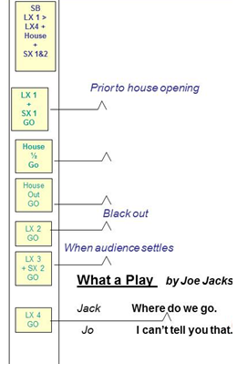

‘Book’ or ‘Call Book’ – some good practice suggestions:
Other important items are usually kept in ‘The Book’ usually in separate divided/tabbed sections:
- contact sheet
- crew schedules
- risk Assessment
- scene change diagrams
- pre-show checklists

SET DESIGNer guidelines
- Ground Plans - the theatre provides designers copies of a ½” scale ground plan of the stage
- two copies of your design are required accurately drawn on the plan - one for the lighting designer and one for the technical staff to lay out your design on stage
- CAD drawings are acceptable
  - ground plan must be submitted before the “build” date for your set
  - .dwg or .dxf or SketchUp CAD files can also be provided
  - provide a fully accurate scale drawing for everything you want built and painted
  - print outs and PDFs do not always retain their scale

- Masking and sightlines are a critical part of the design
  - the theatre has a proscenium with black overhead and side masking – can be used to affect the final appearance of your design
  - an “open concept” design should include your layout and trim of the masking

- Models (maquette)
  - very useful - additional designer’s tool
  - ensure all aspects of the design are fully understood by the entire production team and for discussions with the TD

- Design pointers
  - a large number of flats, doorways, windows, stairs, pillars, trees and other scenic elements are available in-stock
  - review the stock database or portfolios with the TD
  - arrange to visit the warehouse if you need to see a particular piece

- Rehearsal floor
  - a simple, accurate ground plan will be needed to be taped on the floor by the first “read through”
  - can be changed or adjusted with the Director up until building starts
  - ensure drawings are adjusted accordingly

- Scenic Painters
  - we provide professional support – please advise the TD if you wish to do some or all of your own painting
- Process Timelines
- Preliminary Designs - provide to Director and TD prior to first production meeting, include:
  - models or renderings and simple ground plans
  - scene change demands.
  - preliminary list of set dressing items, props etc
  - TD will assess the feasibility of the design prior to support final working drawing.

- Completed Designs - produced based in consultation with the Director and TD no later than 7 weeks before Opening Night, to include:
  - ground plans showing proposed masking and storage areas for all scenic elements in multiple scene shows
  - technical drawings detailed enough to allow building to be initiated
  - no need to include framing or detail construction drawings
  - must include dimensioning from all relevant angles (i.e. Top, Front, Side views etc.)
  - significant section drawings to show proposed positions for scenic elements, masking, and for locating potential electrics, projectors, speakers or other special rigging or installations
  - flown elements are to be shown in their high trim (storage) position.
  - set models are to be to scale (¼”=1’0” or ½”=1’0”)
  - painter’s elevations drawn to scale
  - colour swatches - note PARA paints are our primary source
  - properties and set dressing lists including working drawings or other visuals of specific items.
  - projection information including projection equipment and surfaces, relative positions, and a comprehensive guide to image content (where applicable).
  - detailed description of all special effects

- Approved Designs – approved by Director and TD no later than 6 weeks before opening
  - allows sufficient time for sourcing of materials, construction, painting and technical rehearsals.
  - no purchases will be made before full design approval

projection Guidelines
- Equipment
- State of the Art projection system complete with 8500 lumen HD Projector located in our tech booth. We have two zoom lenses: one that is capable of filling our 34’ x 16’ proscenium opening and the other for projecting smaller images down to 16’x 12’.
- Macbook Pro with Qlab which is a very versatile video cuing program capable of triggering complex video demands with a signal mouse click. Qlab enables us to also project on multiple custom surfaces anywhere in the projection field – i.e. you can have any number of screens or projection surfaces around your stage and use one projector to project on all of them at once or one surface at a time or any combination therein. Qlab can also send video from one computer to multiple screens and even blend these images.

- Challenges
- This technical capability opens up a whole new world of possibilities and although it can be magical when used in the right way it is important to remember that it doesn’t happen by magic and needs to be well thought through and very well planned.
  - there are two particular challenges that will need to be well considered and implemented:
Conceptual - you need to fully integrate the projection into the production
  - although projection may seem on the surface like an instant, ultra-realistic set piece, it is important to remember two of its core attributes: projections are formed by light and they are 2D. If you place 3D actors in front of a projection and expect it to look as real as a scene from a movie, you are going to be disappointed. For projection to work well you will need to be very clear about how it fits into the design and the production both practically and conceptually.

- Technical Coordination
  - projection requires very close coordination between set, lighting, and sound. Your set designer needs to fully integrate the projection surface(s) into their design. Lighting Designers will need to rig and focus to reduce spill on the screen and work to adapt lighting levels as necessary. If your video has sound, your sound designer will need to arrange to hook into the sound system (relatively simple if it is stereo – more complex if it is surround-sound).

- Video personnel - consider three areas
- Video Editor to produce the video clips – you may also a need camera operator
- Projection Technician (someone to take responsibility for projections through tech weeks –Production Support is available to train and assist with Qlab)
- Video Operators (it is best that video is operated by the lighting op)
- it may well be that you could have one person take care of all of this but it is highly unlikely that you will find someone with both the skills and the time to pull all this off.

- The Process and Deadlines
- give your video editor a very detailed brief
- the Director should meet with the projection team at the very beginning of the production process and schedule times/deadlines to view rough cuts throughout the rehearsal period.
- bring your Director, Video Editor, Projection Technician, Set Designer, Lighting Designer and Sound Designer together in the same room to discuss projection as soon as possible (i.e. before set designs are due) make sure everyone understands how important projection is to the production and what they will need to contribute to make it a success
- you should invite your editor to a rehearsal and take the time to tell them not only what you want but where and how it is to appear in the show – the more you want them to contribute creatively, the more they will need to attend rehearsals
- it is very important that a first draft of all the footage is ready as early as possible in tech week (i.e. in the first days). Ideally the Director has already seen and approved the videos by the previous week – it is better to have all the videos in very rough shape than to have only a few very polished videos. If need be, you should have the editor produce space holders where videos are not yet available (e.g. a jpeg or movie with simple word description).

In Qlab all video files must in a compatible format:
Compatible | Sometimes Compatible | Never Compatible
.mov (best option).mp4 or.mpeg | .avi | .wmf

The Tech team is available for consultation and training on what is possible and in the set-up of projectors and Qlab

CLEAN-Up
Please ensure all common areas, in particular the Rehearsal Hall and Green Room, are left clean and orderly after use. All dishes should be rinsed and put in the dishwasher (dishwasher started when full); garbage and recycling put in the correct containers, and all lights turned off. Do not leave any food out. There are specific plastic bins for each show for food that does not need to be refrigerated. Please put all non-refrigerated food in your show’s plastic bins.

Please label all production food with your show title and any personal items with your name. The refrigerator in the Green Room kitchen is for use of the show on stage, shows in rehearsal should use the refrigerator at the bottom of the stairs leading to the stage. The refrigerator is cleaned-out between shows so label it or lose it!

Please note: there is no cleaner on “dark” days - so be extra diligent in cleaning up after yourself.

FOOD SAFETY
Kitchen facilities are available upstairs and downstairs but are not designed for full scale cooking or baking. The upstairs kitchen is intended for bar service and stage food preparation, the Green Room kitchen for cast and crew food preparation.

For pest control – please ensure that no food or food scraps are left out overnight!
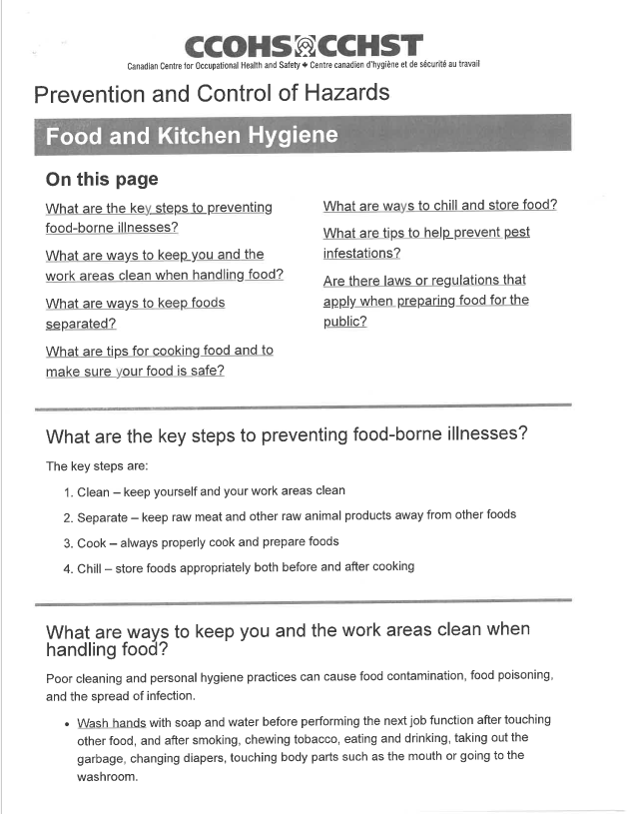

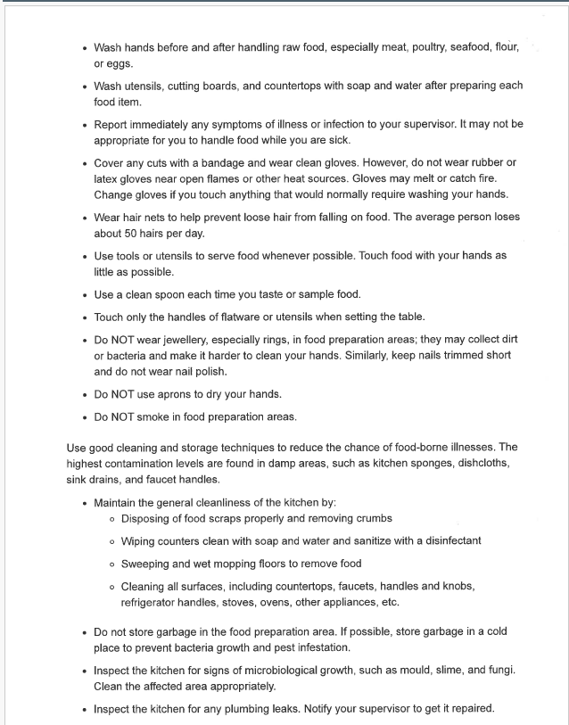

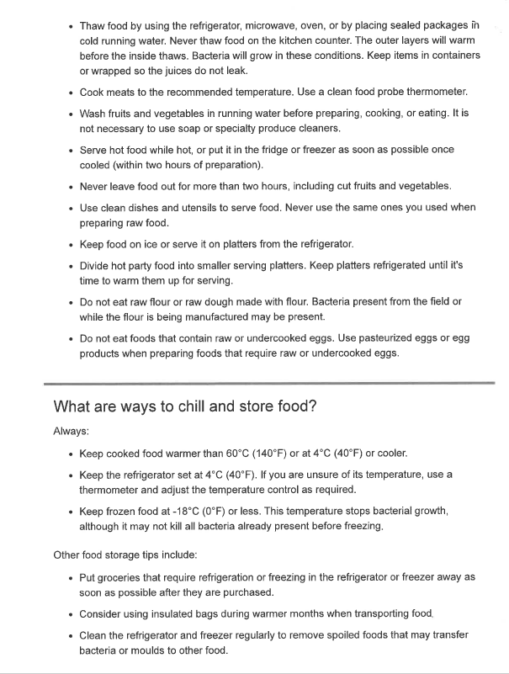
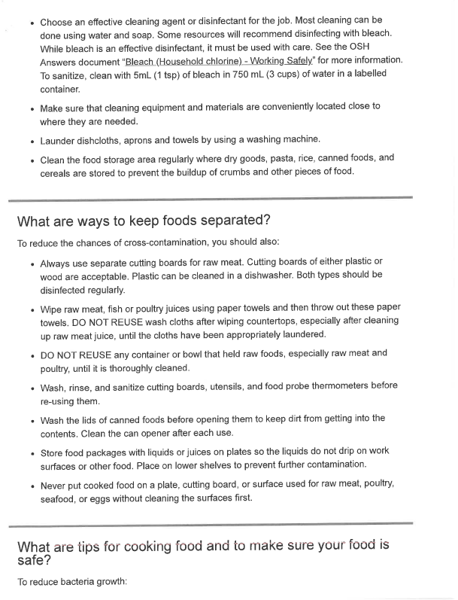
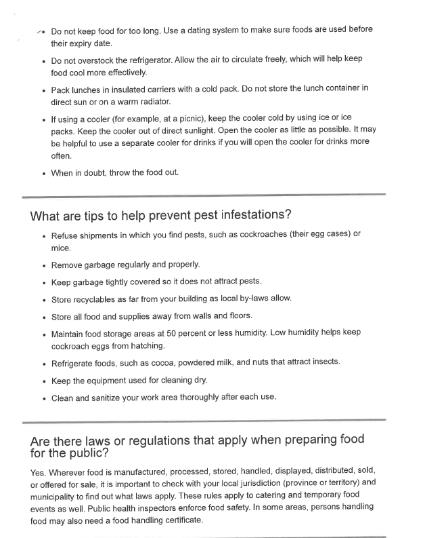
When in doubt throw it out!

BACKSTAGE ETIQUETTE
- refrain from talking aloud backstage - especially last fifteen minutes before show time
- watch what you say over the headsets
- give actors their space
- when in doubt ask the SM
- know the next day’s schedule before you leave after rehearsal/shows
- if you used it, put it away where it belongs - if you don’t know where it belongs, ask
- pay attention when moving - backstage can be a dangerous place
- do not place personal items on the props table
- remove cups, bottles, etc. from backstage area each night

SHOW TIME!

Previews
All shows can benefit from audience feedback prior to opening night. To this end, the majority of shows include a paid preview.
- previews can be offered to companies and non-profit groups:
- corporate previews to entertain clients or as a staff appreciation event
- benefit previews to non-profit groups as a unique fund-raising method
- previews generally occur on the Sunday afternoon before opening, but could also be on the Friday
- production teams are given at least five weeks’ notice of previews
- previews may be cancelled due to insufficient ticket sales

Director’s Notes after opening
- some Directors like to watch the show every night and give notes
- once the show opens, all notes should be communicated via the SM/ASM; some notes change timings and this can affect the operators (lights, sound, costumes, crew)
- if the Director prefers to give the notes directly, then discuss with the SM/ASM
- SM may know something that could affect how or when the notes should be given

Guidance for Show Days
- cast and crew members must check in with the AD each night upon arrival at the theatre
- check in with the SM/ASM when entering or leaving the stage area
- backstage area under the supervision of the SM will be kept clean, tidy, and free of unnecessary clutter
- all valuables should be left in the care of the stage manager – do not leave them in the dressing rooms
- actors generally remain in dressing rooms or Green Room until “called” to backstage
- cast members who smoke should not exit building in costume before/during performance
- cast/crew should instruct visitors to access downstairs through door next to the box office
- coats in the cloakroom should be picked-up before heading to the Green Room
- no visitors can access the stage, wings, auditorium, foyers, etc. unaccompanied or without the knowledge of the SM/ASM
- all visitors should be escorted from the building to make certain the building is secure
- visitors and guests are not permitted in the dressing rooms

LIQUOR LICENSE REQUIREMENTS
No personal alcohol may be consumed in the lobby or house,
and no drinks purchased at the lobby bar may be taken downstairs
This is the law

Special Events and Parties!
OLT has had more than 112 years of traditions for social activity and each company determines how it wants to organize events. - there are some traditions for consideration:
- crew night party - generally the last Friday night of performance: an old tradition is to have the cast feed/water the crew on this night as a thank you
- on closing night, a member of the Board of Directors will thank the cast/crew, the Chair of the Volunteer Committee thanks volunteers and hands out “first-timer” pins, and a member of the Artistic Quality Committee will award the President’s Medal for contribution above and beyond, and thank the Director, cast and crew
- Directors often use this opportunity to thank everyone for their hard work
- closing night: a traditional party night, but it is also strike night on stage and time must be devoted to returning props and costumes, and cleaning-up the dressing rooms

AFTER THE FINAL CURTAIN!

The Strike
Strikes will be carried out after the final curtain on closing night:
- department heads, designers and/or crews are asked to clear the set and stage wings of all props, costumes, furniture, set dressings and fixtures, return items into storage or prep them for load out and transport
- those not assisting with the set can help strike the costumes from the dressing rooms, return items into storage or prep them for laundry or cleaning.
- cast should take their costumes and props downstairs - all personal items must be cleared out of the dressing rooms
- electrical and sound cabling needs to be disconnected and returned to storage. The strike of the Structural Elements of the set:
- at this point, the stage is considered a construction site, volunteers must wear hard hats (supplied by the theatre) and safety boots (must be supplied by individuals) as per Occupational Health and Safety Regulations
- the fridge must be cleared - please advise the AD of the upcoming show what food you are leaving for them
- anything labeled as your show (or unlabeled) is garbage and will be thrown out
- remove all flowers and cards and ensure the dressing rooms are clear.

Strike Protocol
  - strike starts 30 minutes after curtain - time for the audience to leave the house and the cast and crew to toast the production
  - during this time, the stage should be clear of actors and crew until masking can be cleared
  - House Managers will give the audience 10 minutes to clear the house then gently encourage stragglers to move up to the lobby and close the house doors as soon as possible
  - immediately following the 15 minutes (when given the all-clear by the TD) all set dressing props and costumes must be removed from the stage by the designers and props team
  - at the same time any ‘floor based’ lighting and speakers should be removed – if safe to do so
  - actors must clear all items from the dressing room BEFORE going to the party
  - once costumes/set dressing/props are removed, the stage becomes a construction site and the removal of the set will begin - only persons with the permission of the TD and wearing required PPE (i.e. hard hats and safety footwear) are permitted on stage at this time; no one who has consumed alcohol may return to the stage strike
  - Makeup, Props and Costumes Designers must attend strike or appoint a competent replacement to coordinate the return of supplies and cleaning of the dressing rooms
  - All make up, props, set dressing, costumes etc. must be put away in its assigned place.

POST-PRODUCTION MEETING/ EVALUATION PROCESS
A post-production meeting will be scheduled by the Artistic Quality Committee for each production as an opportunity to discuss what worked, what didn’t, and how we can improve our systems and procedures for future productions:
  - production leadership will be invited to attend the meeting
  - at the end of each run, the Artistic Quality committee with send the show AD a survey to be sent to all cast and crew soliciting feedback on their experience in that production.
  - this invaluable feedback will also inform our lessons learned and our objective to continuously improve our productions at the OLT.

AND THAT IS THE PROCESS - THANK YOU FOR YOUR DEDICATION AND COMMITMENT!!

SECTION 4 - COMMUNICATIONS INFO

The theatre has a volunteer Communications Committee, coordinated by Jane Morris, which manages house programmes, website, e-blasts, video trailers, show promotion, media relations and subscription renewal.

House Programme

Credits:
The deadline for submitting cast and designer bios, cast and crew names, and any special credits to be included in the house programme is five weeks prior to opening night (exact date provided by Val Bogan):
- the AD gathers and completes the information needed in the same layout and order as outlined in the template, and provides it to the house programme coordinator, Val Bogan (vbogan1171@gmail.com)
- the information required is outlined in the Production Form titled ‘House Programme Credits Template’ on the website

Director’s Notes:
Director’s notes offer a way for our audience to “glimpse behind the curtain”; information about the process, the vision or concept for the play; context, etc.
Some ideas:
- when the play was first written
- when the play was first produced
- famous people who may have played roles in previous productions
- interesting facts about the play
- challenges the director may have had with regards to the script
- why the play was chosen, how it relates to the theatre

Artwork for Posters and Social Media
Artwork of the season’s visuals can be made available to the AD to print colour posters for the cast and crew to promote the play within their own communities, offices, clubs, churches, etc. Different digital formats of these visuals can also be distributed for individual use online.

Headshots
Two to three weeks before show opening, any headshots required will be taken (See AD checklist for details)

Promotional Photos
Sometime before the on-stage rehearsal period, rehearsal or backstage photos may be arranged to obtain images useful in the marketing and promotion. Costumes need not be 100% complete, nor are all cast members necessarily required. A location for the photo shoot may not involve the set.

Production Photos and Video Shoot
- one week prior to opening, production photographs will be taken for the website, media and archives.
  - actors and crew need to be advised that full costume and makeup are required
  - the AD will coordinate with the OLT’s photographer Maria Vartanova (mariavartanova@hotmail.com)
- On the same day, the OLT videographer will shoot footage/clips for a short promotional video for local media, social media and the OLT website.
  - The AD will coordinate with videographer Ian Gillies (ianargillies@gmail.com)

Media Relations
Media relations are overseen by a Media Relations Subcommittee, whose members are Christian Giansante (c.s.giansante@gmail.com), Karine Charland (kcharland@hotmail.ca), and Lindsey Keene (me@lindseykeene.com). The Subcommittee’s role is to:
- build sustainable relationships with media representatives
- ensure that all productions receive similar amounts of media and social media coverage
- promote the quality and consistency of media-related content such as press releases and social media posts

For each production, a member of the Subcommittee is supported by a volunteer media liaison chosen by the production’s director. The media liaison can be a member of the cast/crew, or a separate person dedicated to this role.

For each production, a Subcommittee member will write a draft news release, submit it to the media liaison for input and director approval, then distribute the news release and photos to a media contact list to solicit interviews, listings and reviews. Some production members, generally the director and possibly one or more cast members, may be asked to give a media interview, which could include costumes and props, or even reenacting a short scene from the play.

The Subcommittee member will liaise with the production’s media liaison to find interviewees and ensure they are well prepared, and to obtain photos and videos of rehearsals to post on social media.

All communications to external media representatives (producers, hosts, reviewers) are sent out through the following email: communications@ottawalittletheatre.com.

Subcommittee members and media liaisons are guided by the Media Relations Checklist on OLT’s website (Production Resources).

Photos and Videos
- photos and short videos (ideally a minute or less) can be used to promote and create awareness/buzz for your show
- each production’s media liaison should periodically take photos and videos of rehearsals and/or compile photos and videos taken by other cast or crew members
  - please send rehearsal photos and videos to Christian Giansante - these can be action shots, costumes, props, set-pieces, mini-cast interviews, in-character introductions, non-spoiler snippets of a scene; anything to create interest and give the “insiders” a ‘feel’ for the show

do you have an idea that might help sell your show?
- are you personal friends with media personalities or producers?
- let your Media Liaison know

In addition to the Communication Team’s work, there are also many things that you can do either on your own or with our support to help market your show.

Facebook
- There is an OLT Facebook page and a Facebook group.
- The Facebook page called “Ottawa Little Theatre” is the public face of OLT. Please “like” the page on Facebook and encourage your friends and family to do so as well - like and share posts. Postings can only be made by the administrators, but anyone can comment: https://www.facebook.com/ottawalittletheatre/ Liking, sharing, or commenting on posts on the OLT page makes it more visible to our audience, so don’t be shy!
- The Facebook group is called “Friends of Ottawa Little Theatre”. This is where we post volunteer opportunities, audition notices, interviews, etc. You are welcome to post here as well – photos from rehearsals, fun experiences, etc.: https://www.facebook.com/groups/ottawalittletheatre/

Instagram
https://www.instagram.com/theottawalittletheatre/
- you are encouraged to “follow” on Instagram
- you can “like” our posts and repost them
- if you are creating original content promoting OLT please mention @theottawalittletheatre on Instagram so we can like and repost as well
- everyone who has a social media account is encouraged to use it to promote their OLT involvement to their followers

Production Blog
Cast and crew members are encouraged to blog about their production for the OLT’s website under “News,” or disseminated through social media.
- blogs give a sneak peak of what audiences can expect from the show, or a sense of the people involved in the show
- blogs should be human in tone, describe choices/experiences in the play, acting styles, design choices, the rehearsal process etc. - photos are very helpful
- someone could document the rehearsal and production process for the blog:
  - set design, inspiration, challenges, key features, maquette photos
  - costume designs – drawings, builds, concepts etc.
  - reflections on the historical context of the play
  - funny, interesting, difficult, personal anecdotes from rehearsal
  - photo essays from rehearsal

Other
- Groups (15+) receive a group discount ticket price.

If you have any ideas, suggestions or, are able to help promote the show in any way please discuss with the Media Relations Coordinator.
We always need good ideas!

SECTION 5 - HEALTH AND SAFETY

At the OLT, the safety of the public and everyone here takes priority in all areas - there is no task so urgent that it cannot be completed safely.
Assess Risk: Before starting any activity, ask yourself:
- Is there something that could go wrong?
- If yes - Could these hazards result in me or someone around me needing first aid?
- If yes - What could be done to make things Safer?
- If yes - Will those things make it safe enough?
- Do I know enough to answer questions ‘1 - 4’? (i.e. Do I need expert advice?)
- Considering all of the above should I be jumping into this or should I seek advice?

Be Cautious:
- ‘The show must go on’ – but not if it is going to risk you or someone else getting hurt.
- Don’t rush – stay calm – keep your wits about you Breathe – Think – Then Act.
- Don’t be too ‘gung-ho’: If it is heavy – GET HELP / If it’s a bit dangerous – DON’T RISK IT / If you don’t know how -- ASK! If you think you shouldn’t – DON’T!

C (see) a Hazard or Incident, Report It:
- See a trip hazard pick it up or move it right away;
- See something dangerous – warn people and report it to the PM, TD or SM;
- See a near miss or almost have an accident – report it (we need to take steps to prevent it from happening again – next time someone may get hurt).

We have a duty not to put ourselves or others around us at risk. Directors and ADs (and SM on stage) have an enhanced responsibility for Health and Safety for your Actors and Crew particularly in rehearsals. To help the production team identify potential risks, there is a simple check list – in our Production Forms and Checklists - when in doubt ask the TD or PM for advice.
Download Risk Assessment
Any activities that present a significant risk should be “risk assessed”

Are You Lifting Correctly

P | lan your route (is the path clear - are there doors)
P | ersonal Protective Equipment (Should you use Safety footwear, Gloves etc.?)
A | ssistance (Get help to lift- it’s not a competition)
A | ids – Lifting Aids that is (e.g. Could you use a dolly or cart?)
L | egs – Lift with your Legs – not your back
L | ook straight ahead – not down – (This will keep your back straight)
S | traight – Lift straight do not twist
S | peak to your partner when lifting – (Lift on 3 or 1,2,3 Lift? – be clear)

SECTION 6 – EMERGENCY PROCEDURES

Responsibility of the Stage Manager and House Manager

If at any time during the run of a show a Fire Alarm or any other emergency requiring the building to be evacuated occurs, it is the duty of the employees and volunteers to assist patrons with information and firm direction regarding evacuation of the theatre environs.

It is imperative that the volunteers and employees remain calm and competent. It is important that patrons easily identify volunteers and employees of the Ottawa Little Theatre.

The following fire evacuation procedure is designed to move people out of the building as quickly and safely as possible.

If you see fire or smell smoke notify FOH Manager and call 911. Notify SM that fire department has been called and location of fire.

On an alarm, the Front of House Staff and Volunteers will immediately proceed to their assigned stations. If there is any other threat, the SM will inform the Front of House and technical staff so that they may take their positions.

- the Stage Manager/House Manager will make, or delegate, the Sound Operator to make the following announcement:
Your attention please. All patrons are asked to calmly leave the building by the nearest exit. Staff and Volunteers are standing by to assist you.
- repeat announcement;
- drop the Fire Safety Curtain;
- ensure stage area has been cleared then go directly to Besserer St. (Stage Door) exit;
- ensure that the Besserer St. doors are open;
- ensure that the washrooms at the Besserer St doors are vacant, and assist patrons to make a swift and orderly exit; once clear, and close doors;
- proceed externally to "Enunciator panel" via the outside of the building if it is safe to do so to report that the stage area is clear and to meet fire department.
- FYI – Instructions on how to complete two of the tasks normally fulfilled by the Stage Manager are below:
- house announcement microphone is on the left of the Stage Management station between the desk and the wall (attached to the desk).
- microphone is accessed from front or rear of the desk. It is recommended that you proceed to the back of the desk to make the announcement so that you can also access the fire curtain from the same spot.
- there is a switch on the mic: switch it on and talk. The script you need to read is posted on the rear of the desk.
NOTE: ADs covering for an SM are already responsible for evacuating the downstairs areas (described below) and will need to have a responsible person cover regular fire evacuation duties when they go upstairs.
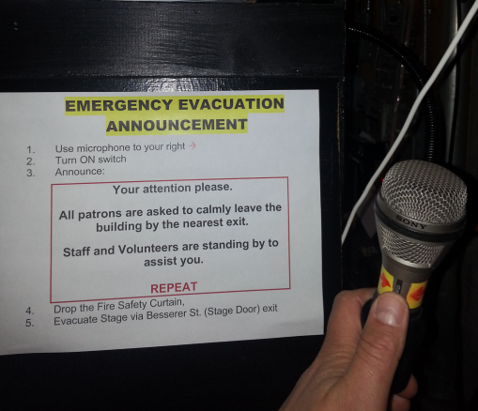 | 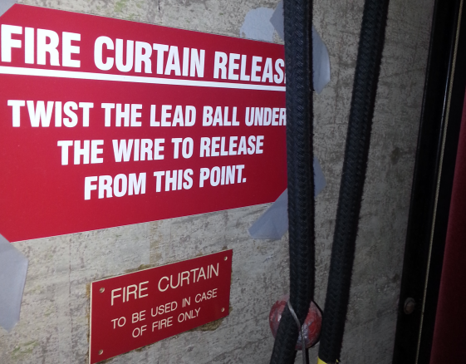 | - You must ensure no one is under the Fire Curtain before releasing it  - ONLY use the Fire Curtain in the event of a fire

Fire Evacuation Procedure (excerpts relevant to ADs/ Cast and Crew)

- the ADs (or Green Room designate) for the show onstage and the show currently in rehearsal are responsible for ensuring that their people are cleared from the basement area (this includes Green Room, Workshop, Dressing Rooms, Washroom and Production Office).
- ADs will instruct their people to use either the King Edward St. or Besserer St. exits; ensure rooms are empty before exiting; close doors to all rooms once they are emptied before exiting; proceed to “Enunciator panel” (located at the front door) to report All Clear
- volunteers in the technical booth must exit via the North or South roof exits leading to adjacent Hotel Parking Level.

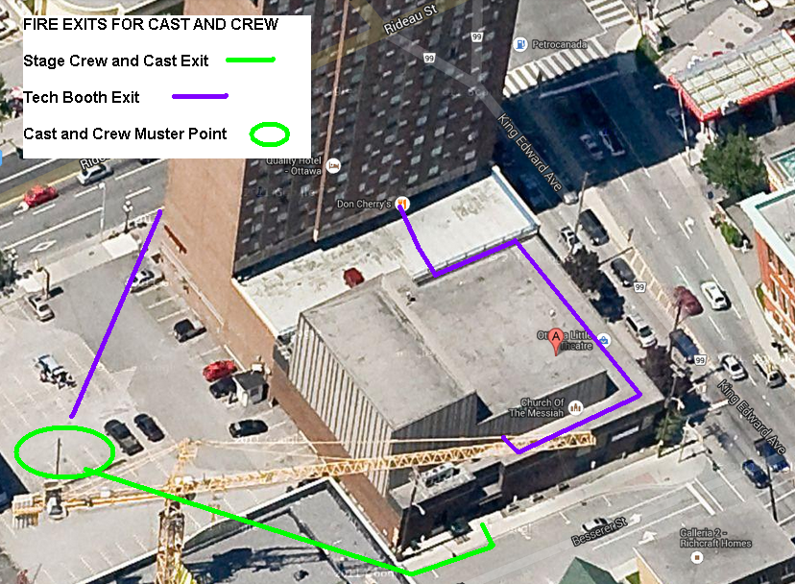

SECTION 7 – INDEX OF ONLINE RESOURCES

The Volunteer Section of the OLT website – www.ottawalittletheatre.com – contains a wealth of useful and important Production Resources to help you with your show, including forms and policies. Here is an index of what you’ll find there.

Production Forms

Forms That Must Be Completed On All Productions:
- OLT Risk Assessment form
- House Programme Credits Template
- Rehearsal Notes
- Assistant Director Expense Form
- Statement of Expense Form - Designers
- Volunteer Information Form

Forms To Use Where Relevant:
- Incident Report
- Under-Age Volunteer Parental Consent Form
- Sign-up Sheet for Party
- Sound Cues Sheet
- Lighting Cues Sheet
- Typical Production Schedule

OLT Policies and Bylaws
- Respectful Workplace Policy and Procedures
- Policy on Activities Involving Children
- Policy on Professional Actors and Directors
- Policy on Bursaries for Theatre Arts Training

Volunteer Role Descriptions
Directors must understand the requirements of the key members of their Production Team because the director is ultimately responsible for ensuring that each of these vital roles is completely in hand:
- Assistant to the Director (see also the AD Checklist)
- Set Designer
- Lighting Designer
- Sound Designer
- Costume Designer (includes OLT Wardrobe Management)
- Properties Designer
- Makeup and Hair Designer
- Additional Volunteer Job Descriptions (crew members, committees, etc.) are available in the same section

